EX:1 Eight queen problem using python code
Aim:
To place 8 queens on a standard 8×8 chessboard such that no two queens attack each other.
Objective:
To implement the Eight Queen Problem using Python and determine a valid arrangement of eight queens on an 8×8 chessboard such that no two queens attack each other horizontally, vertically, or diagonally.
Algorithm:
- Start with an empty 8×8 chessboard.
- Place queen’s row by row.
- For each row, try placing a queen in every column.
- Before placing, check if it’s safe (no queen in same column, left diagonal, or right diagonal).
- If safe → place queen and move to next row.
- If not safe → backtrack (remove queen, try next column).
- Repeat until all 8 queens are placed.
- If row = 8 → solution found. Continue to find all solutions.

Flow chart:
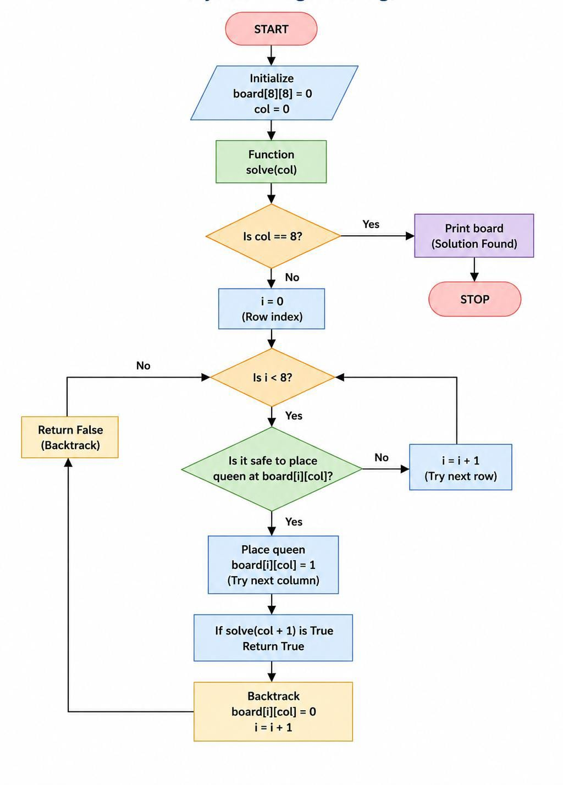
Coding
N = 8
x = [-1] * N
def safe(r, c):
return all(x[i] != c and abs(x[i] - c) != abs(i - r) for i in range(r))
def solve(r):
if r == N:
for i in range(N):
print(" ".join("Q" if x[i] == j else "." for j in range(N)))
return True
for c in range(N):
if safe(r, c):
x[r] = c
if solve(r + 1):
return True
return False
solve(0)

Output
Q . . . . . . .
. . . . Q . . .
. . . . . . . Q
. . . . . Q . .
. . Q . . . . .
. . . . . . Q .
. Q . . . . . .
. . . Q . . . .

Result:
The 8 Queen Problem was implemented successfully using Python, and a valid solution was obtained using the backtracking algorithm.

